Template: Returning Workers EDM in MailerLite (EDM configuration)

Design
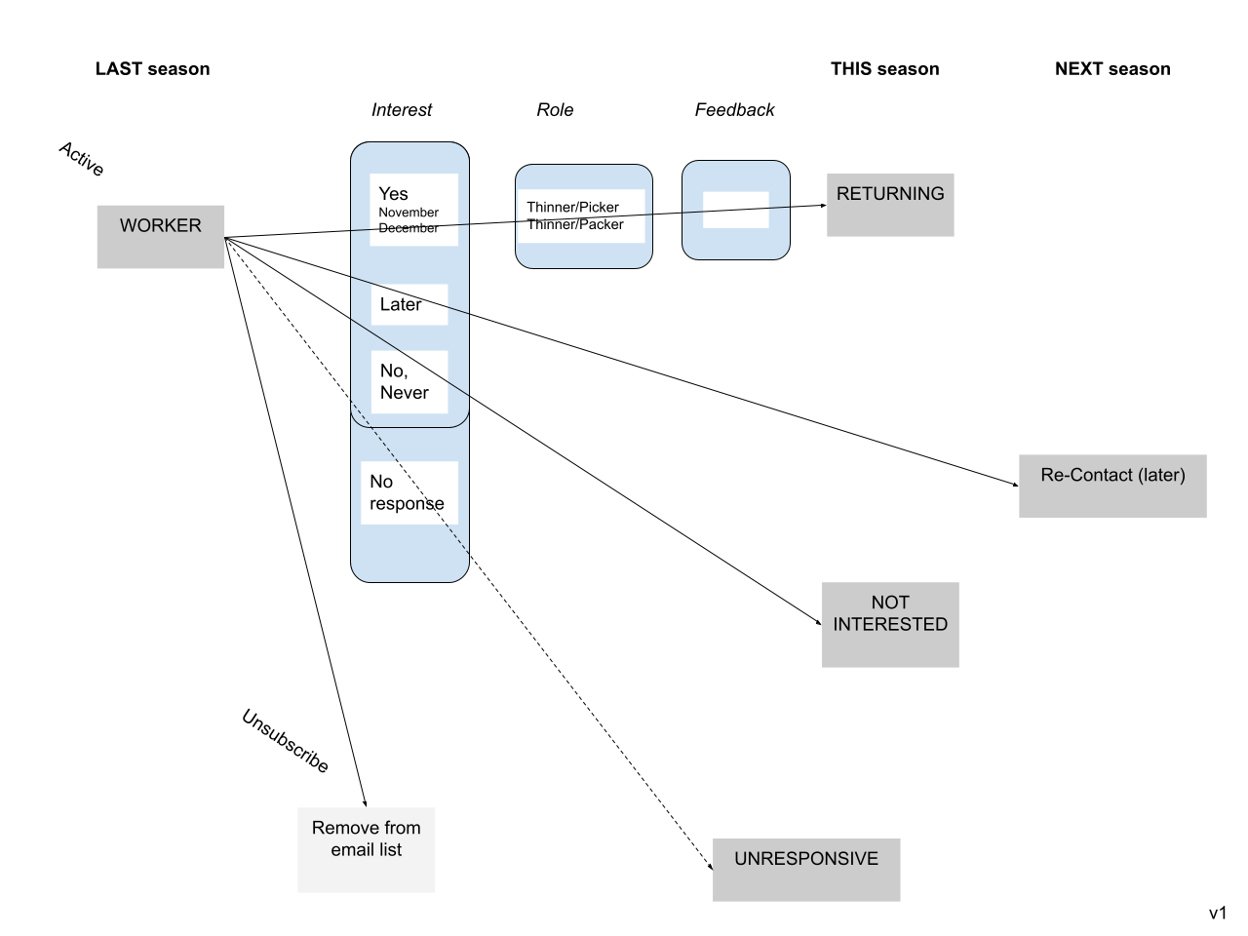

Subscriber Fields
Note these fields are going to be independent each year and should be tagged with a prefix “YYYY |” (eg 2022 | Interest)

Name | Type | Values | Description
2022 | Interest | Text | November  December  Sorry, next season  I’m not coming back  No response | These answers (first four) come from the user entry in form. The last is from the automation
2022 | Role | Text | Thinner/Picker  Thinner/Packer | These answers come from the user entry in the form and can be empty depending on the Interest answer (i.e. should be filled if November or December are answered.
2022 | Feedback | Text |  | This answer comes from the user entry in the form and can be empty.

Subscriber Groups

Name | Description
2022 | Worker | Tag all people that worked for you in this season

Automation Configuration

Element | Email 1 (make contact) | Email 2 (follow up) | Email 3 (last follow up) | Email 4 (going negative)
Delay | immediate | 4 days | 4 days | 4 days
Template | Returning Worker | Returning Worker | Returning Worker | Close out
Calls to action | Returning details
Name | {name}
Subject line (28-50 chars) | Following up last email on returning to {business} | Just in case you missed the last email | Final check on returning to {business} | Sorry you aren't joining us this season
From (23 chars) | {name} at {business}
BODY (50-125 words)
Salutation | Hi again {name}, | {name}, | Hi there {name}, | {name},
Opening text | I'm keen to know if you want to come back and work with us next season—it was great having you last year! Please let us know when you are able to work and what role you would like.  Sign up and bring a friend! | I'm still keen to know if you want to come back and work with us next season—it was great having you last year! Please let us know when you are able to work and what role you would like.  Sign up and bring a friend! | Just a final check to see if you want to come back and work with us next season—it was great having you last year!  Feel free to get in touch anytime. | Sorry that you aren't joining us this season. We've marked you as not available and won't contact you again this season.
Salutation | Cheers, {business person name}. | Cheers, {business person name}. | Cheers, {business person name}. | Cheers, {business person name}.
CTA | Data Collection
Footer  - Unsubscribe  - Links to social  - Company details  - Disclaimer | [Divider line—MailerLite default]  {business}  {business address}  {business contact phone number}  {business contact email address}  You received this email because you worked with us last season  Unsubscribe

Email—Survey Design
See https://www.mailerlite.com/help/how-to-embed-a-survey-in-a-campaign

Question Type | Intro | Multiple Choice | Multiple Choice | Open Choice | Outro
Questions | Help us plan next season | When are you available to start? | What role do you want this season? | We are always looking at ways to be better | Thanks!
Description | Are you joining us this coming season? |  |  | If you could change something at {business name} from last season what would it be? | I'll be in touch about the next steps.
Button | Complete 3 questions
Answers |  | November | Thinner/Picker
 |  | December | Thinner/Packer
 |  | Sorry, next season
 |  | I’m not coming back
Type |  |  |  | Textarea
Placeholder |  |  |  | Optional but always appreciated!
Interaction |  | Answer question and move on all with one click (rather than select and next) | Answer question and move on all with one click (rather than selec and next) | Answer question and move on all with one click (rather than selec and next)
Rules |  | RULE #1: update field  Q: When are you available to start?  Is answered  Update customer field with the answer  CUSTOM FIELD  Interest | RULE #2: update field  Q: What role do you want this season?  Is answered  Update customer field with the answer  CUSTOM FIELD  Role | RULE #3: update field  Q: We are always looking at ways to be better  Is answered  Update customer field with the answer  CUSTOM FIELD  Feedback
RULE #4: skip to end
Q: When are you available to start?
Is answered with specific answer

ANSWER
Sorry, next season
Skip to questions

A QUESTION TO SKIP TO
Q: We are always looking at ways to be better

RULE #5: skip to end
Q: When are you available to start?
Is answered with specific answer

ANSWER
I’m not coming back
Skip to questions

A QUESTION TO SKIP TO
Q: We are always looking at ways to be better

Returning Workers Segments (Reporting)

Name | Group  belongs to | Interest (field)  contains | Role (field)  contains | Description
2021 | Worker | 2022 | Returning | 2021 | Worker | November |  | A person has indicated that they do want to return
 | 2021 | Worker | December
2022 | Returning Worker | November | 2021 | Worker | November |  | A person has chosen the month
2022 | Returning Worker | December | 2021 | Worker | December |  | A person has chosen the month
2022 | Returning Worker | Picker | 2021 | Worker |  | Picker | A person has chosen the role
2022 | Returning Worker | Packer | 2021 | Worker |  | Packer | A person has chosen the role
2021 | Worker | 2023 | Re-Contact | 2021 | Worker | Re-Contact |  | A person has said no to this year but keep them on the list to be re-contacted
2021 | Worker | 2022 | No Response | 2021 | Worker | No response |  | All of the emails had no response (they may have been opened/viewed and clicked but no explicit response.
2021 | Worker | 2022 | Not Interested | 2021 | Worker | not coming back |  | An explicit negative response and not to be contacted

Subscribe List Template

Email Address | First Name | Last Name

